|  |  |
| --- | --- |
| |  | | --- | |  | |

|  |  |
| --- | --- |
| |  | | --- | | **We Have Some Great News ...** | |

|  |  |
| --- | --- |
| |  | | --- | | **Over the past 14 Months we have been working behind the scenes to bring you our most recent release Web Editor 5.0 upgrade. It is now fully integrated as of today December 16th for all Dealers. You can now update and modify virtually any part of your website content. Need Training let** [**Support@turnkeywebsolutions.com**](mailto:Support@turnkeywebsolutions.com) **We are ready to assist wherever possible.** | |

|  |  |  |  |
| --- | --- | --- | --- |
| |  |  |  | | --- | --- | --- | | |  |  | | --- | --- | | |  | | --- | | Visit our Website | | | |

**Upgrades!**

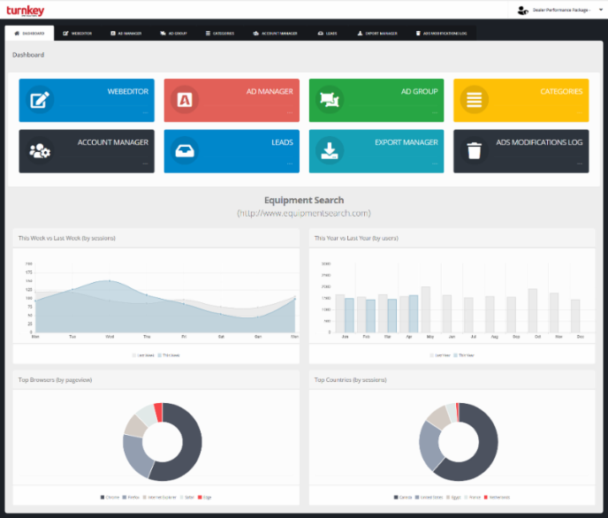**Entirely New Dashboard Interface**

Update your own sliders, Update your own Specials, YOU are in Total Control!

From your dashboard you can quickly navigate between your website and your inventory making this now a all in one user interface.

We are continuing to add further enhancements.

Want to quickly and easily control and export your inventory to Kijiji or Trader? New System can now do this. You must have an account with either however this makes it easy to control and display in multiple marketplaces. Ask for more detail if interested : Market Syndication

|  |  |  |  |
| --- | --- | --- | --- |
|  | |  | | --- | |  | |  | |
|  |  |

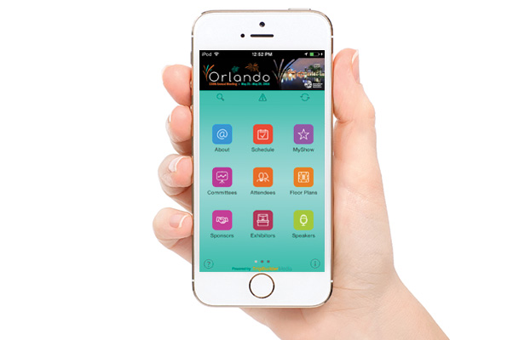**Turn Key Mobile – Jan 2020 Release**

**Working for Tomorrow Today!**

Charging forward we are doing final testing on a completely new mobile app that will allow you to create and post display / inventory ads quickly and easily right from your phone. Even do a complete video walk-around! Android and I-Phone , expect release of this Jan 2020!

**Time Saving New Bolt On’s!**

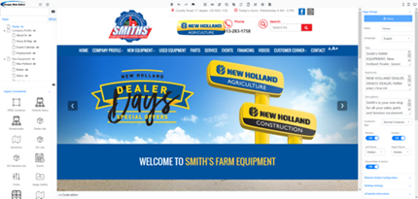**Want to quickly and easily control and export your inventory to Kijiji, Trader or Facebook?** New System can now do this. You must have an account with either however this makes it easy to control and display in multiple marketplaces. Ask for more detail if interested : [Market Syndication](mailto:sales@turnkeywebsolutions.com)



**DMS Integration** - Did you know we can integrate with almost any DMS (Dealer Management Software)

Many dealers are now working with us as their complete and total solution. With DMS integration, it will update and keep current all your wholegoods inventory as well as all parts listings!

We can explain all the additional options now readily available for you - Please reach out to us and we can set up a demo and explanation so your dealership can consider this incredible enhancement. [DMS Integration](mailto:sales@turnkeywebsolutions.com)



**E-Commerce Solution**

**Industries First Total Solution**

Take Deposits on New, Used, All Wholegoods and

Offer absolutely everything your dealership sells online!

**YES!** You can even **sell up all your Accessories**!

**Full Payment Gateway**

**Did you know?**

|  |  |  |  |  |
| --- | --- | --- | --- | --- |
| |  |  | | --- | --- | |  |  | |  |  |     **Windows 7** - while Windows 7 is still in widespread use, its time is now limited. Microsoft will be discontinuing support for Windows 7  *Clients using older software that does not support TLS 1.2 will need to upgrade or patch no later than* ***September 30, 2019****. TLS 1.0 will be disabled on our mail servers after this time and software not supporting TLS 1.2 will no longer be able to connect.* Link to Additional Resources |